1 Circle the correct options.
1 The strongest phone cases is / are made of rubber.
2 To make paper, trees are cutting / cut down.
3 How is / are glass made?
4 Plastic bags isn’t / aren’t used in some countries.
5 A lot of fast food is freezing / frozen and then heated in microwaves.
6 Silk is made from / by insects called silkworms.
2 Put the words in the correct order to make passive sentences.
1 are / in cans / sold / Soft drinks / and bottles / .
Soft drinks are sold in cans and bottles.
2 mixed / To make a cake, / eggs / in a bowl /
are / and butter / .

3 are / to keep the sun out / covered /
Glass windows / in plastic / .

4 here / aren’t / Credit cards / accepted / .

5 to make leather / used / Cow skin / is / .

6 cardboard / made from / What / is / ?

3 Complete the passive sentences with the correct form of the verbs in brackets.
1 The best doughnuts are dipped (dip) in sugar.
2 Where is sushi (eat)?
3 A tin of tomatoes is (need) to make this recipe.
4 Some materials, like glass, are not (recycle) in every country.
5 The water for spaghetti is (boil) before the pasta is added.
6 Some new cars are (drive) by robots.
4 Match the beginnings (1–6) with the endings
(a–f) to make sentences.
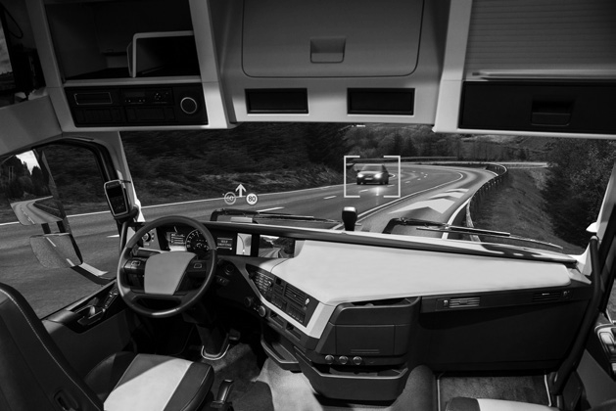
1 The first driverless cars were a
2 The Pyramids in Egypt were
3 The telephone was
4 The Nintendo Wii wasn’t
5 The world’s tallest building wasn’t
6 The first footballs weren’t
a invented in the 1920s.
b designed by Steve Jobs.
c built by thousands of workers.
d invented by Alexander Graham Bell.
e made of leather.
f built in London.
5 Complete the passive questions with the correct words.
1 Where was the first language spoken?
2 Where the Olympic Games first organised?
3 was the internet invented by?
4 Who was Romeo and Juliet written ?
5 Who was penicillin by?
6 Who the Sagrada Familia designed by?
6 Match the questions (1–6) in Exercise 5 with the answers (a–f). Then complete them.
a It was spoken in Africa. 1
b It by Alexander Fleming.
c They in Greece.
d It by Gaudí.
e It by Tim Berners Lee.
f It by Shakespeare.

